Maskanajy

25/04/2018

The information in this document relating to: - Nahr Development Methodologies, programs, products and services is to be treated as confidential and a trade secret of Nahr Development and is not to be used or disclosed except to the recipient's employees, officers, and agents or contractors engaged in evaluating this document, and who are subject to appropriate written undertakings consistent with this confidentiality and use restrictions.

Portal

Dear Sir,

First of all, we really appreciate your interest in Nahr Development, and hope to match your expectations.
Nahr Development is pleased to offer you its professional services in developing your Portal, insuring combining latest UI Experience and development techniques in order to ensure delivering the right message to targeted Users, and building your project’s image.

We fully understand your needs for this project, and hereby confirm our commitment to meet those needs to the best of our abilities at the highest professional and needed quality levels.

We would appreciate your comments, modifications or changes that you may deem necessary.

Looking forward for a mutual fruitful cooperation and you are welcome to contact us at any time.

Yours sincerely

Ahmed Mukhtar
Technical Manager
Nahr Development

Table of Contents

Contents
Maskanajy 1
Table of Contents 3
Contents 3
Objective 3
Implementation details 4
1. Design 4
2. Portal and Mobile APP Home Page 4
3. Property listing 5
4. Property Details 5
5. User Registration / Login 5
6. My Account 5
7. About/Services 5
8. Contact us 6
9. Sitemap 6
10. Backend 6
11. Property Management Backend 6
12. Booking Listing 6
Scope, Warranty and Maintenance 7
Assumptions 7
Te chnologies 10
Financials 10
Validity of proposal: 10
Delivery 10
Payment terms: 10

Objective
Maskanjy Properties need to build a portal and Mobile APP to provide a centralized content management system and communication tools with its Customers. The Portal will help the Corporate to present and Market its Properties and manage its Services and any needed content.
The Portal and mobile app and its integration with social media will be used as a communication tool which will help in obtaining new Communication and engagement level.
Nahr Development is aiming to create strong and attractive Portal that helps The client to Achieving this objective

Implementation details
Portal
A fully dynamic, easy to update Portal.

Portal Modules:

Design
Nahr Development will provide a creative design matching the client corporate identity, after creating the design Nahr Development and The client will work together to understand any needed modifications and amends on the design until reaching the clients satisfaction and get its approval.

Portal and Mobile APP Home Page
  - Attractive design matching The customer identity.
  - Main navigation bar for the Portal .
  - An attractive animated photo rotator displays the Featured Properties.
  - Filter by Price/Rooms/Check In / Check out /area
  - Login/Registration
  - Featured Properties
  - Add to Favorites
  - Footer contains all links of all sections.

\

Property listing
This Section will contain the following services:
  - List of all properties
  - Property Details
  - User can filter using the following criteria :
  - Chekin date, Check out date
  - Number of rooms
  - Price range

Property Details
A details page to show the details of the properties, which will contain the following items:
- Photo gallery
- Description
- Address
- Basic information like space, number of rooms..etc
- amenities
- Price
- Booking
- Reserve button
- Social media integration

User Registration / Login
In this form the user can register and login to manage his favorites and bookings

My Account
Here the user can manager / cancel his booking of apartment

About/Services
Content page which the admin can add/modify its content through the backend CMS

Contact us
This section will be dynamic content section managed through the backend administration system.
Contact us Form for Users to send email

Sitemap
Direct links to all sections

Backend
From backend application the Portal administrators will be able to manage the content of all sections contains view, add, modify and delete all content and data of custom applications.

Property Management Backend
Admin will be able to add the following :
- City
- Home Type
- Number of bedrooms
- #of Beds
- #of Bathrooms
- Bed Type
- Descriptions
- Location on google map
- Amentias like (TV, Heating, Internet…etc)
- Photos
- Pricing :
  - Base Price
  - Cleaning Fees
  - Week End Price
- Particular Date Pricing (calendar)

Booking Listing
Here list all reservations through the website where the admin can approve the booking and book the apartment.

Scope, Warranty and Maintenance

Assumptions
While building the proposed solution, the following assumptions should be considered according to our understanding of the project requirements:

- The customer will assign one person to be trained on the Content management of the solution. This person needs to have some knowledge using web portals.
- We will deliver the final project contain the initial content as provided to us by The customer , however, your administrator(s)/content editors will be responsible for maintaining and managing the Portal content once the project is closed and delivered.
- All content, whether text or images, will provided to us in digitized format. Text will be provided in word or rtf format and not scanned images.
- The customer Should provide Us with the following Items:
  - Permissions Matrix.
  - High Res. Logo .
  - Color Schema if Available.
  - Sample from the Content.

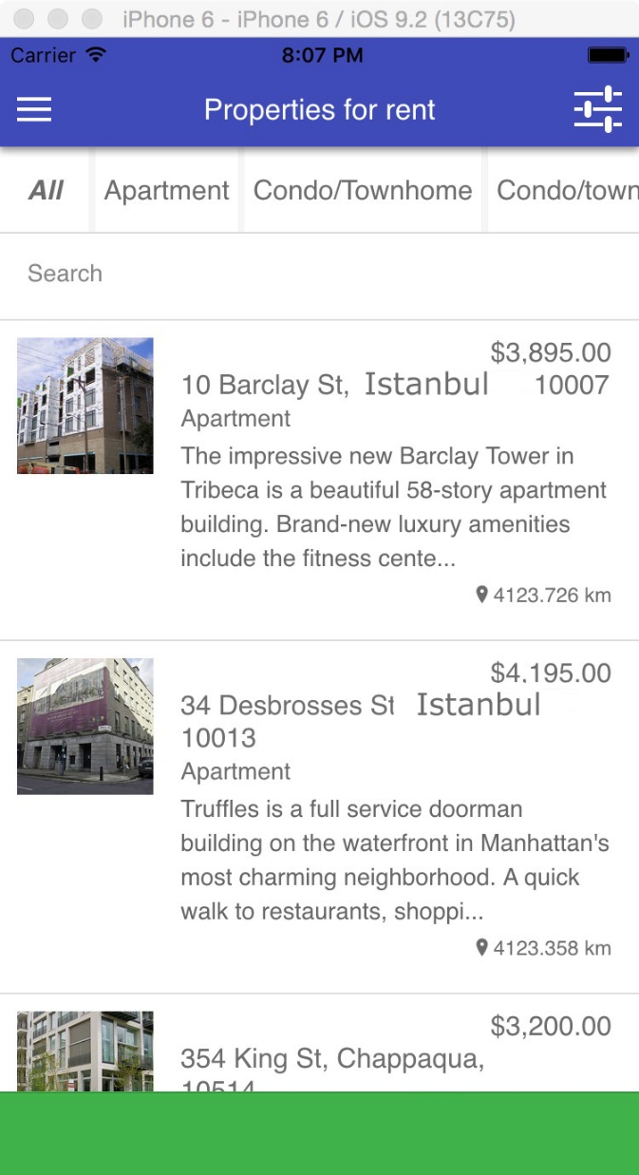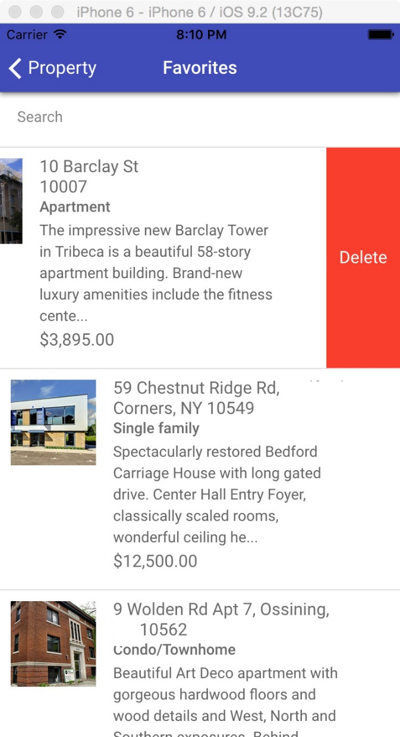

Figure 1 Home Page Listing Figure 2 Favorites

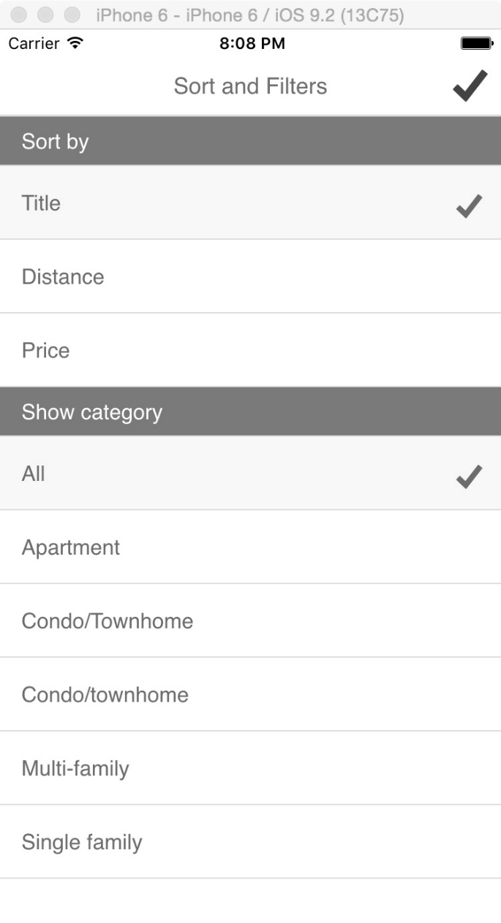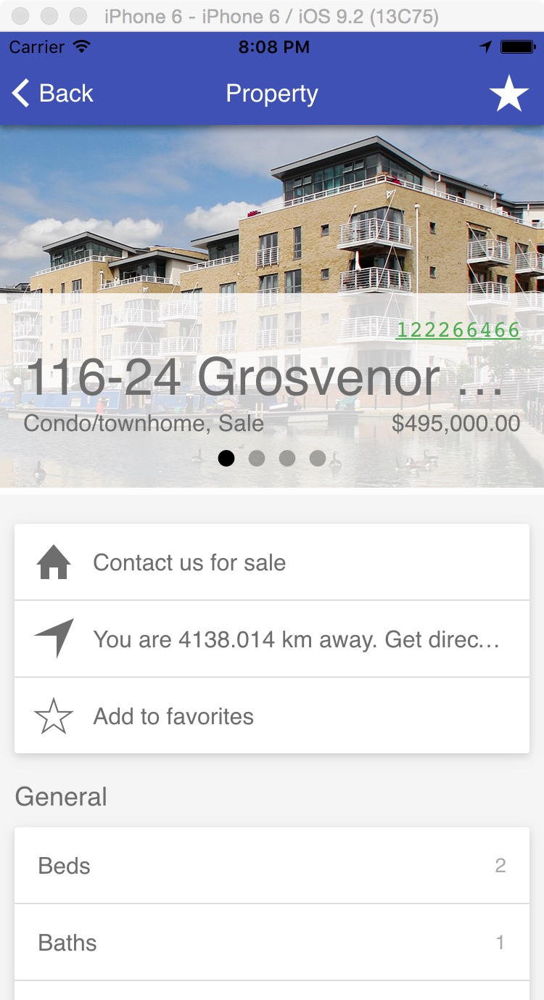

Te chnologies
Nahr Development will use the following technologies in designing and developing throughout the project lifecycle:
- MVC6
- MSSQL 2016

Financials

